PART 4: The Challenge
Background: Smart Parking Barrier System.
A local university wants to implement a smart parking barrier system at its main gate. The
system should:
- Automatically open the barrier for registered staff and students.
- Count the number of cars in the parking lot.
- Display the number of available spots.
- Trigger an alert if someone tries to enter when the parking lot is full.

The goal is to simulate and implement the logic using the Integrated Problem-Solving Process.
Step 1: Understand and Define the Problem (Analyse)
The university needs a smart parking system that allows only registered staff and students to enter, counts cars, shows available parking spaces, and gives an alert when the parking lot is full.

Step 2: Organise and Describe the Data
Data | Description | Example
Vehicle ID | Identifies the vehicle | V001
Registration | Checks if the vehicle is registered | Registered/Unregistered
Parking Count | Number of cars currently in the parking lot | 50
Parking Capacity | Maximum number of cars allowed | 100
Available Spots | Spaces still available | 50
Gate Status | Shows whether the gate is open or closed | Open/Closed
Alert Message | Message when unregistered or parking is full | Access Denied/Parking Full

Step 3: Plan the Solution (Design the Algorithm)
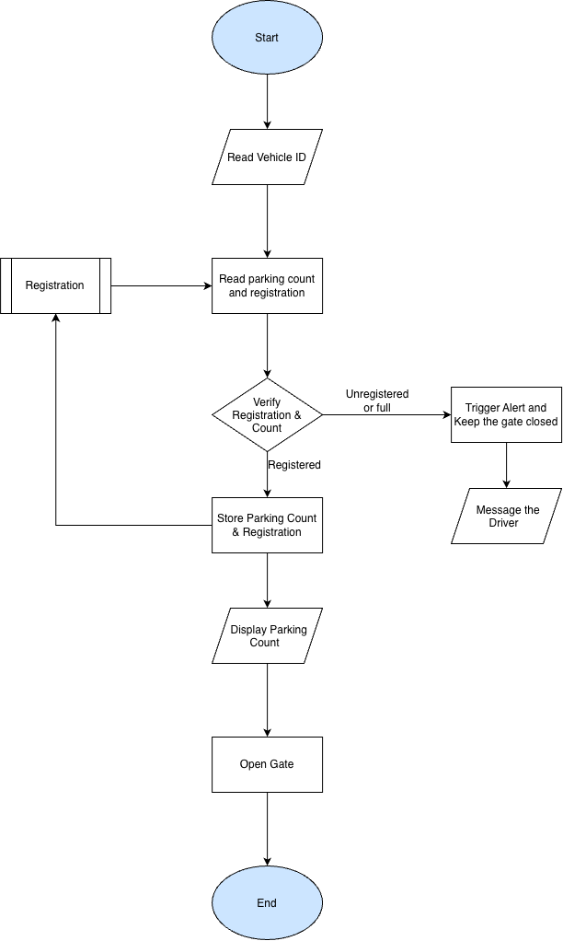
Step 4: Implement the Solution (Word Coding)
Once upon a time…
Read the vehicle ID.
Check the registration and current parking count from the “Registrations” database.
If the vehicle is unregistered, keep the gate closed, trigger an alert and display a message to the driver.
If the vehicle is registered but the parking lot is full, keep the gate closed, trigger an alert and display “Parking Full”.
If the vehicle is registered and parking is available, update the parking count, display the available parking spaces and open the gate.
All transactions are stored in the “Registrations” database.

Step 5: Test and Refine the Solution (Debug and Verify)
Assumptions:
Max number of cars allowed: 100
Registrations database is up to date(actual car park spots availability)

Test Case | Expected Result
Registered user with 95 cars | Allow entry, update count to 96 and open gate
Registered user with 100 cars | Alert + gate remains closed + “Parking Full” message
Registered user with 101 cars | Error/invalid count because parking should never exceed 100
Unregistered user | Alert + gate remains closed + access denied message

